Satellite Power Systems Research
Christopher Kalitin

Papers
Astroforge - Spacecraft Power 101
https://www.astroforge.com/updates-collection/spacecraft-power-101

Astroforge - Spacecraft Solar Array Structures
https://www.astroforge.com/updates-collection/solar-arrays

A Comprehensive Review on CubeSat Electrical Power System Architectures
https://www.researchgate.net/publication/353971086_A_Comprehensive_Review_on_CubeSat_Electrical_Power_System_Architectures

Comprehensive analysis of Cubesat electrical power systems for efficient energy management
https://www.researchgate.net/publication/390372857_Comprehensive_analysis_of_Cubesat_electrical_power_systems_for_efficient_energy_management

Design and Implementation of Electrical Power System for ISRASAT1 Cube Satellite
https://www.researchgate.net/publication/313559628_Design_and_Implementation_of_Electrical_Power_System_for_ISRASAT1_Cube_Satellite

A Low Cost, Efficient Electrical Power System Design for CubeSat
https://www.researchgate.net/publication/372977694_A_Low_Cost_Efficient_Electrical_Power_System_Design_for_CubeSat

CubeSat 101: Basic Concepts and Processes for First-Time CubeSat Developers
https://www.nasa.gov/wp-content/uploads/2017/03/nasa_csli_cubesat_101_508.pdf
This provides a good high-level overview of each small sat system.

A Guide to CubeSat Mission and Bus Design
Artemis CubeSat Kit
https://pressbooks-dev.oer.hawaii.edu/epet302/
See chapter 5 (page 677 of the pdf) for power systems

Astroforge - Spacecraft Power 101
https://www.astroforge.com/updates-collection/spacecraft-power-101

3 primary systems:
- Generation
- Distribution
- Energy Storage

Power modes:
- Minimum Power (cease attitude control, low comms, shut down most avionics)
- Safe Mode (Maintain attitude control for maximum irradiance on arrays, broadcast telemetry)
- Earth Comms Mode

Astroforge’s first spacecraft had dual 35 W flight computers, poses issues for minimum power mode. Can have a backup low-power microcontroller to handle essential spacecraft systems in minimum power mode.

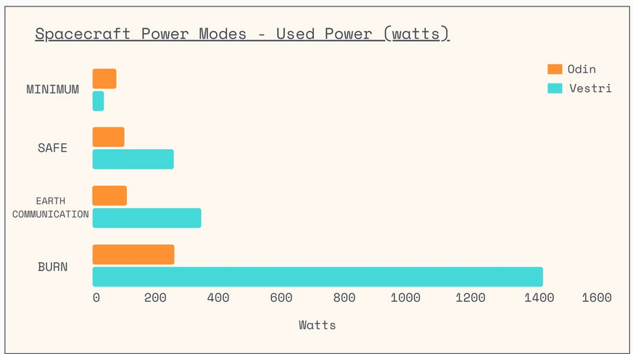

Odin:
Minimum Power: 76 W
Safe: 101 W
Earth Comms: 110 W
Burn: 260 W

Vestri:
Minimum Power: 36 W
Safe: 258 W
Earth Comms: 345 W
Burn: 1432 W

Arrays:

Odin max power generation:
160 W

Vestri max power generation:
2047 W

Power loss due to suboptimal solar angle follows cosine curve:
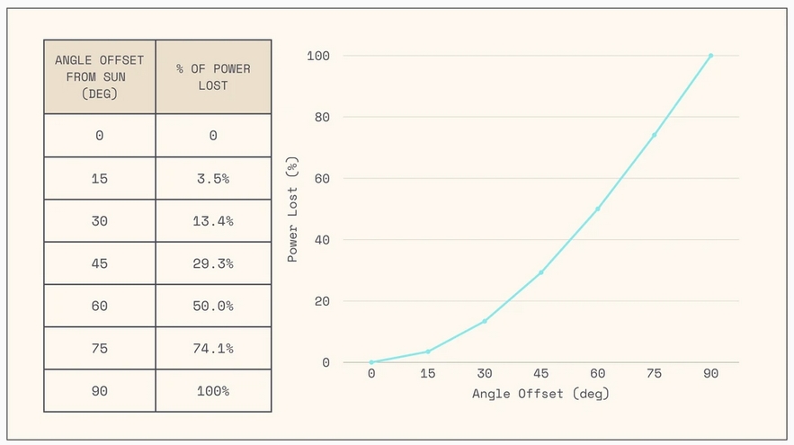

You get diminishing returns as you get closer to 0 degree offset from the sun’s normal vector towards your spacecraft, don’t need perfect attitude control.

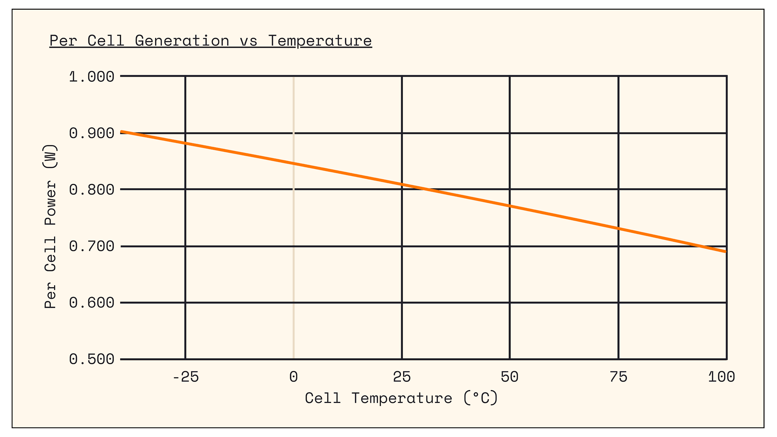

Cell power falls by about 0.2% per degree C

Nominal power: 0.8 W / cell (~25 C)
Slope: -0.0016 W/°C

Coverglass darkening & atomic displacement are radiation effects that caused ~2-4% cell capacity degradation per year.

Odin’s panels:
- Made by Pumpkin Space systems
- Standard triple-junction cells on a fiberglass (PCB) substrate.
- Glass encapsulation for radiation protection
- 2 wings, 3 panels each, each panel 30 W.
- Each panel was an independent string, so if any one string failed on ⅙ power loss

Vestri:
- Semi-rigid cell structure that’s ~25% efficient
- 341 W per panel, again 2 wings 3 panels each
- Glass encapsulation replaced with polymer spray, less degradation
- Semi-rigid cells attached to honeycomb sandwich panel substrate, very lightweight at ~120 W/kg all in for arrays.
- 1 panel exposed while wing is stowed, so you get 341 W even without deployment
- Make everything multi-fault tolerant (Odin’s release mechanism was not).

Batteries:
Odin:
- 4x 100 Wh batteries. 2x per string.
- Off-the-shelf power system with fixed maximum charge of 90% of full capacity. 90 Wh usable energy storage per battery.
- Can’t reach full output power at <25% charge, so effectively 65 Wh usable capacity per module.
- Ensure you have the capability to share power between power system sides (Side A / Side B)

Distribution:
Power System Regulator:
- Constant 28 V bus voltage.
- Overvoltage protection is done here.

Without a regulator your bus voltage is in the range of minimum battery voltage and max solar array voltage. Over-voltage protection has to be done on each load, not centralized.

More importantly, solar arrays don’t operate at max efficiency. MPPTs!

MPPTs allow for inefficient power conversion when batteries are charged, instead of shunting excess power to heat on the bus, you can keep that heat on the arrays.

Two MPPTs drawing from the same arrays using a power sharing diode (so current can’t backfeed from one array to another I assume?). With two MPPTs on the same string essentially, solar array voltage collapsed.

Solution was to run one MPPT at minimum power (100mW) at a time.

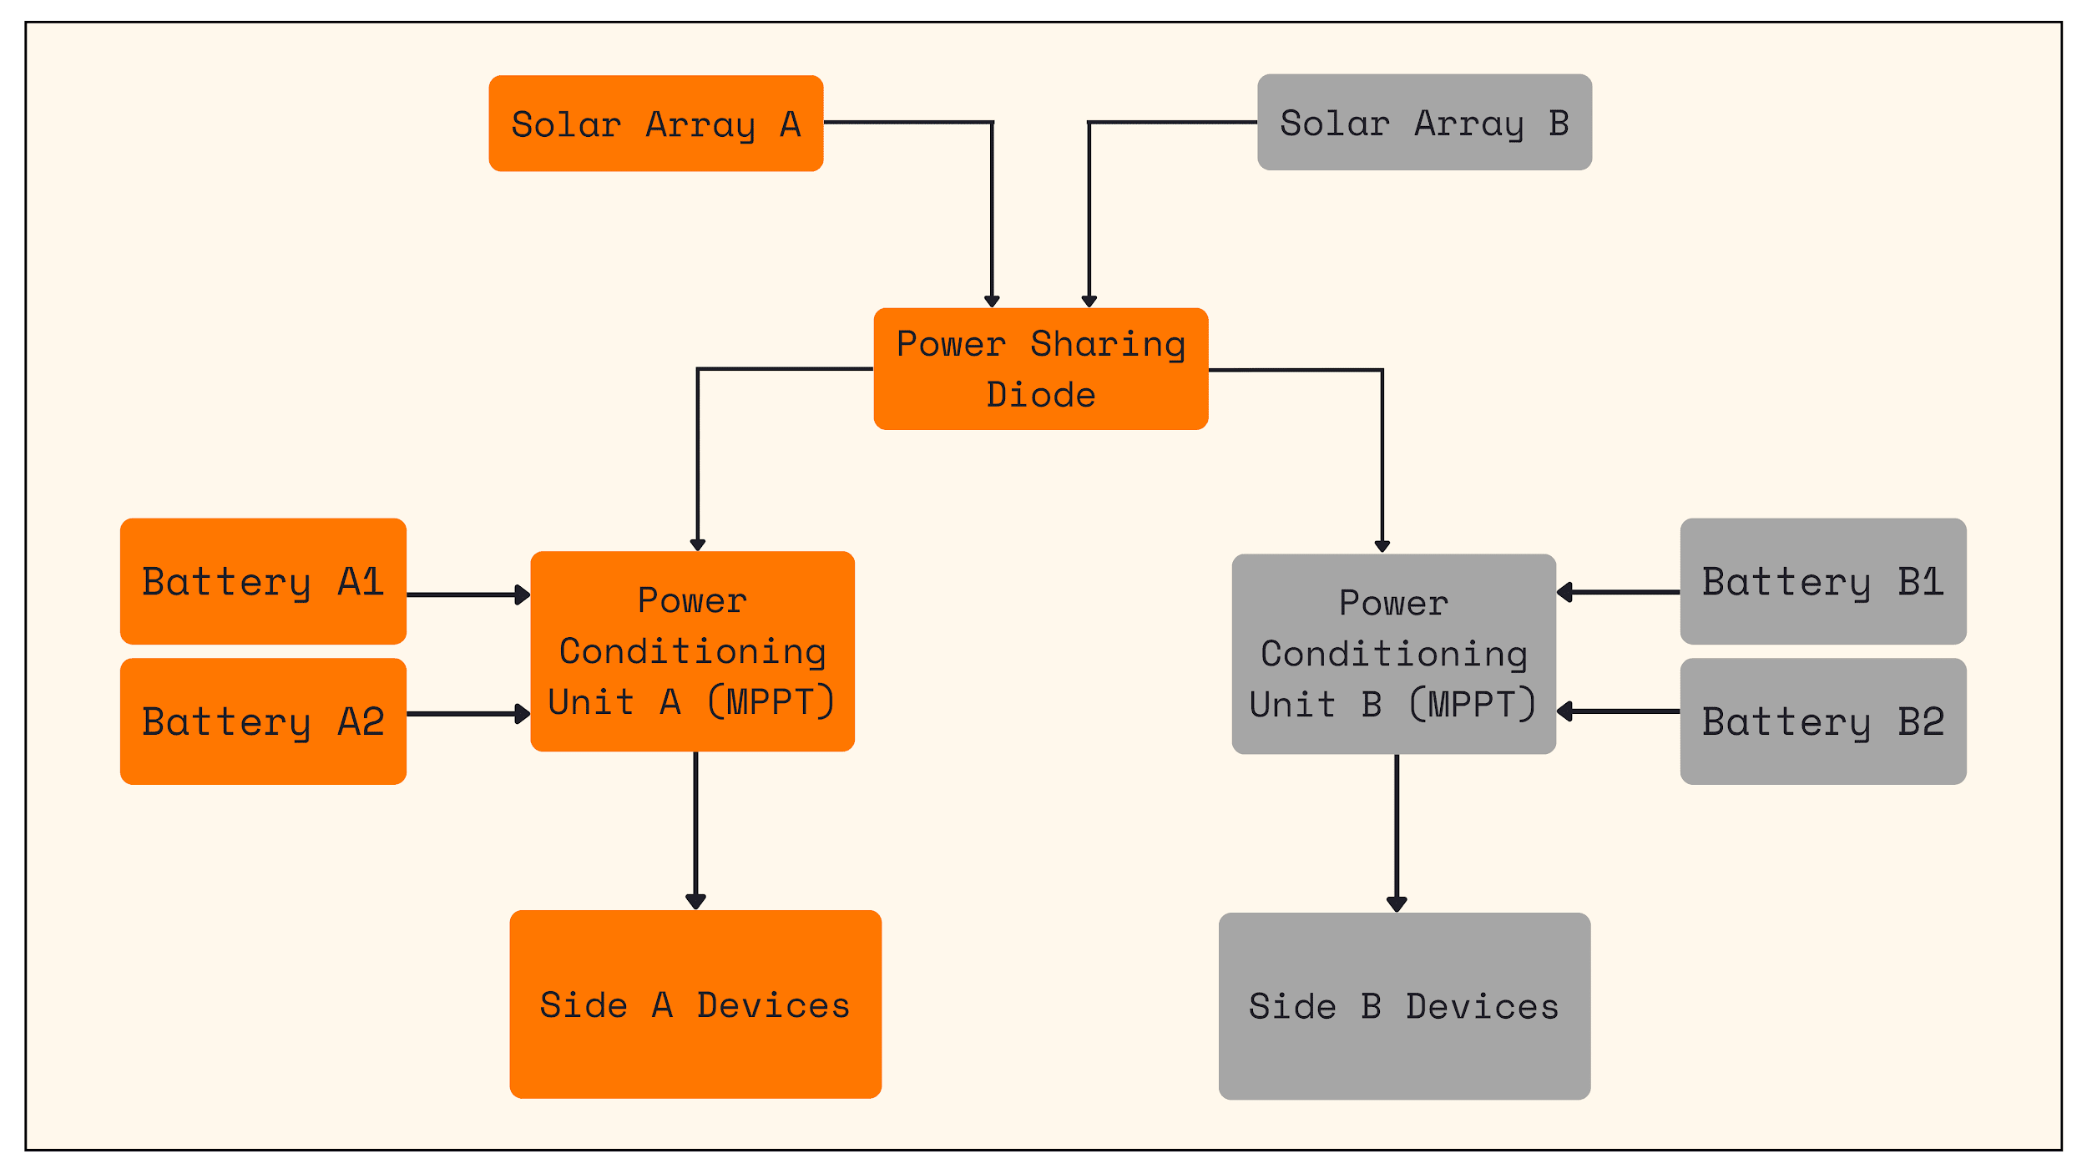

Shunt resistor is a big block of metal on the satellite. Make sure it’s always connected!

Diodes introduce power losses, best to have separate strings + MPPTs that interface downstream of the power regulation.

On Vestri, Overvoltage shunt eliminated because excess power surges (<50 ms) can be redirected into the battery until the MPPT can reduce power from the arrays.

Another Astroforge blog post solar array structures:
https://www.astroforge.com/updates-collection/solar-arrays

Paper: Design and Development of an Electrical Power System for a 3U Cubesat
See pages 127-146
https://link.springer.com/chapter/10.1007/978-981-19-7198-3_13

Components:
- Li-ion battery (With UV and OV fault control)
- DCDC with 3.3 & 5 V output busses + unregulated bus
- Surface-mount & deployable solar panels

Most 3U <10 kg sats use <30 W.

Again: generation, storage, conditioning.

Blocking diodes on solar panel to battery path to prevent reverse polarity.

DCDCs contain the over-temp and over-current protection.

In sun-sync:
- 95 minute total orbit
- 62 minute sunlit
- 33 minute eclipse

Here’s a diagram:
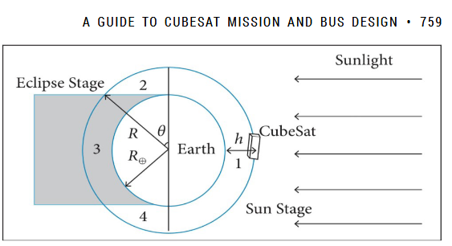

Power modes of 3U sun-sync satellite:
- Payload Operation
- Detumbling
- 3 axis acquisition
- Data transmission

Power budget:
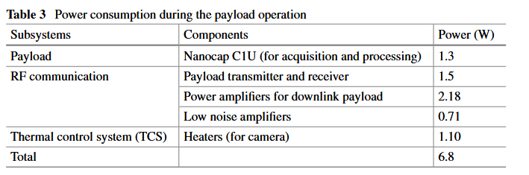

Power control system (showing energy flow):
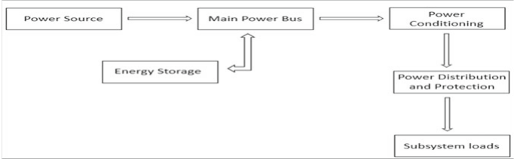

30% triple junction GaA solar cells used.

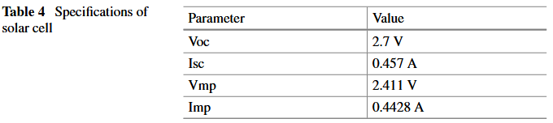

Power consumption net budget:
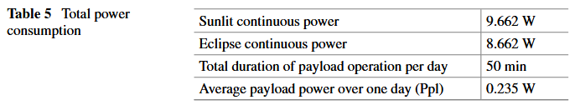

System Tool Kit (STK) software sim software used to get orbit power parameters (the 95 / 62 / 22 min numbers above).

Power conditioning typically 85% efficient. Distribution and battery typically 90%.

After deployment the satellite is tumbling, 5 orbits budgeted to detumble with magnetorquers. This defines battery size requirement, detumbling time.

Using an 18650 module.

TTC = Telemetry, Tracking, and Command
OBC = On-Board Computer
ADCS = Attitude Determination and Control System

High-level power budget:
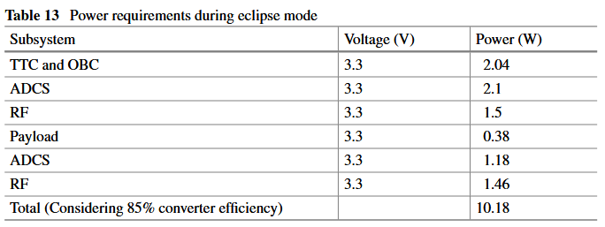

3S3P used with 10.5 V nominal, 12.6 V max. 110.5 Wh.

Battery can’t discharge below 30% during detumbling operations (so that orbital operations can be done afterward). Also required that eclipse mode energy not exceed 20% of battery capacity.

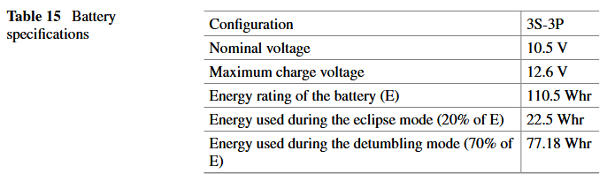

DCDC specs:
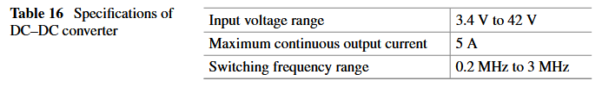

DCDC: LT8640
- Low ripple
- Low EMI
- High operating junction temp
- Adjustable PWM frequency
- Resistor programmable variable output voltage
- Internal switches ultra-low drain to source resistance
- Internal switches ultra-low quiescent current

DCDC outputs 3.5 V and 5.2 V to account for power distribution switch voltage drops.

1M + 412k or 243k resistors used to set DCDC output voltage divider.

Electrical Power System Schematic:
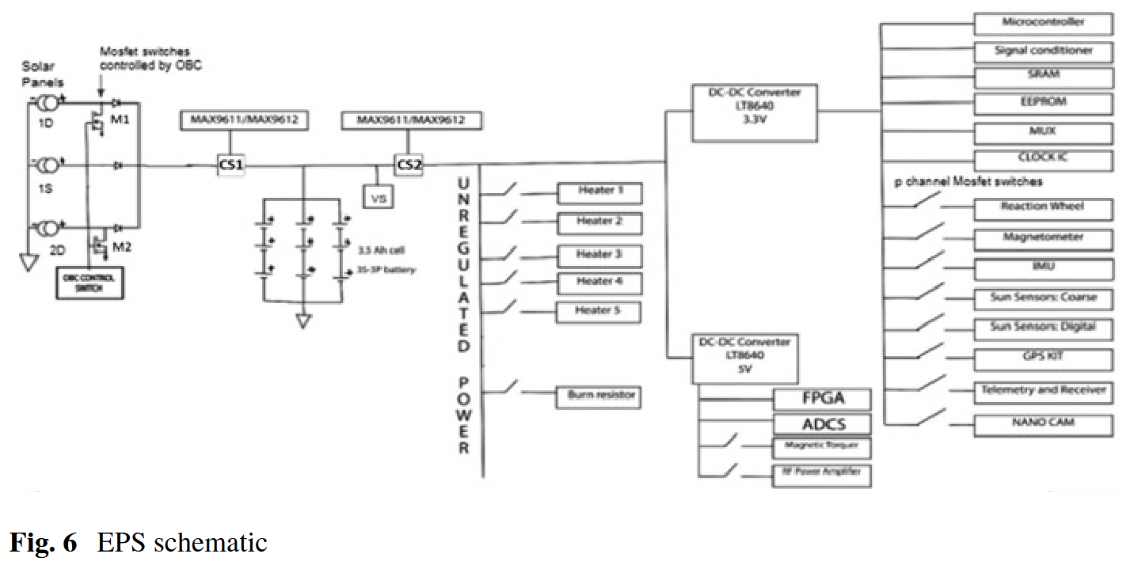

Each panel is 7 cells in series. Each panel obv in parallel.

Shunt resistor used for current sensing on solar array output. 10-20 milliohms.

Another shunt resistor on battery output to satellite power systems.

You get both charge and discharge current and take the sum.

Unregulated power is fed to five heaters for battery and payload. Heating only in sunlight to limit battery discharge in eclipse. 5V supplied to magnetic torquer (ADCS) and RF and FPGA (TTC And OBC). Power distribution switches are P-channel MOSFETs.

They created a Matlab model of solar cells, battery, loads.
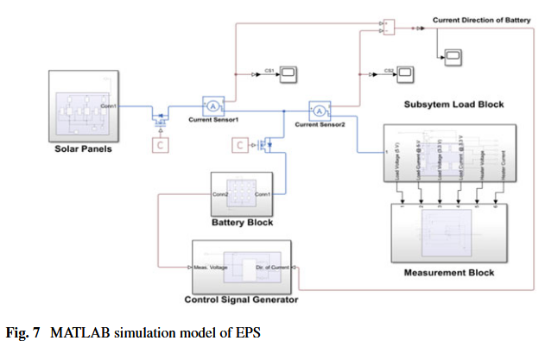

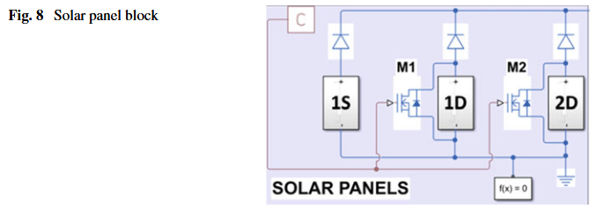

UTP: Upper threshold potential
LTP: Lower threshold potential

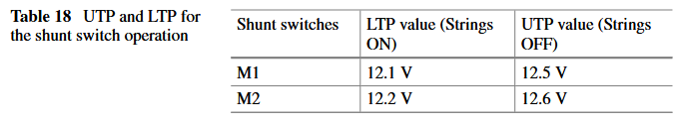

Shunt switches are used to prevent current output from solar arrays going to the battery.

3 arrays (1S, 1D, 2D) meaning stationary or deployable. Only 1D and 2D have shunts. Not clear what the shunts go to or what that “C” block is.

A Comprehensive Review on CubeSat Electrical Power System Architectures
https://www.researchgate.net/publication/353971086_A_Comprehensive_Review_on_CubeSat_Electrical_Power_System_Architectures

